-----------------------------------------------------------------------------------

Assignment 3: Retrieve data using Group By clause

-----------------------------------------------------------------------------------

**Sample table1:Department**

-dept_id

-dept_name

**Sample table2: Employee**

-emp_id

-dept_id

-mngr_id

-emp_name

-salary

-- Create Table

CREATE TABLE Department

(

dept_id INT NOT NULL PRIMARY KEY,

dept_name NVARCHAR(50) NOT NULL

);

CREATE TABLE Employee

(

emp_id INT NOT NULL PRIMARY KEY,

dept_id INT NOT NULL,

mngr_id INT,

emp_name NVARCHAR(50) NOT NULL,

salary MONEY NOT NULL,

FOREIGN KEY (dept_id) REFERENCES Department(dept_id)

);

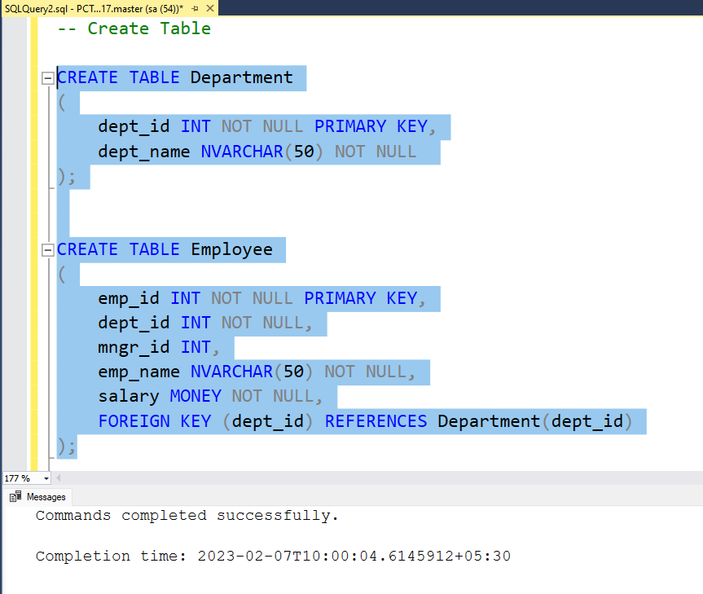

--Insert Queries

INSERT INTO Department VALUES

(1001,'Finance'),

(2001,'Audit'),

(3001,'Marketing'),

(4001,'Production');

INSERT INTO Employee VALUES

(101,1001,NULL,'Kayling',6000),

(102,3001,101,'Blaze',2750),

(103,1001,101,'Clare',2550),

(104,2001,101,'Jonas',2957),

(105,2001,104,'Scarlet',3100),

(106,2001,104,'Frank',3100),

(107,2001,106,'Sandrine',900),

(108,3001,102,'Adelyn',1700),

(109,3001,102,'Wade',1350),

(110,3001,102,'Madden',1350),

(111,3001,102,'Tucker',1600),

(112,2001,105,'Adnres',1200),

(113,3001,102,'Julius',1050),

(114,1001,103,'Marker',1400);

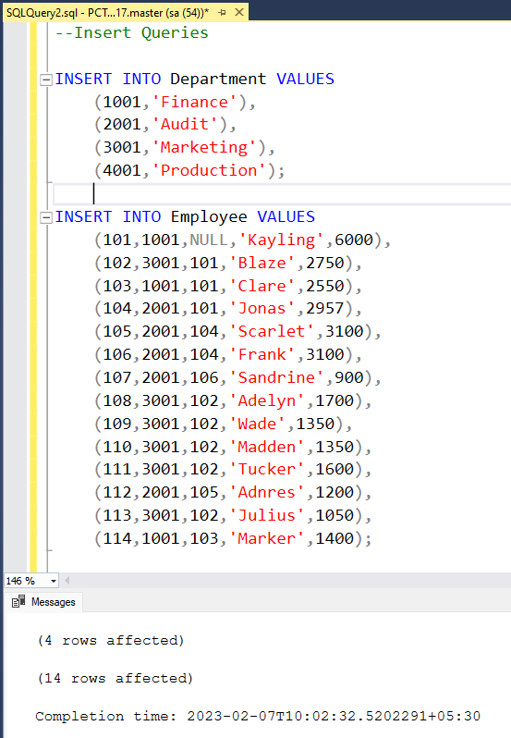

1. write a SQL query to find Employees who have the biggest salary in their Department

Ans:

**Query:**

select emp_name,Salary,dept_id from Employee

where Salary in (select max(salary) from Employee group by dept_id)

**Output:**

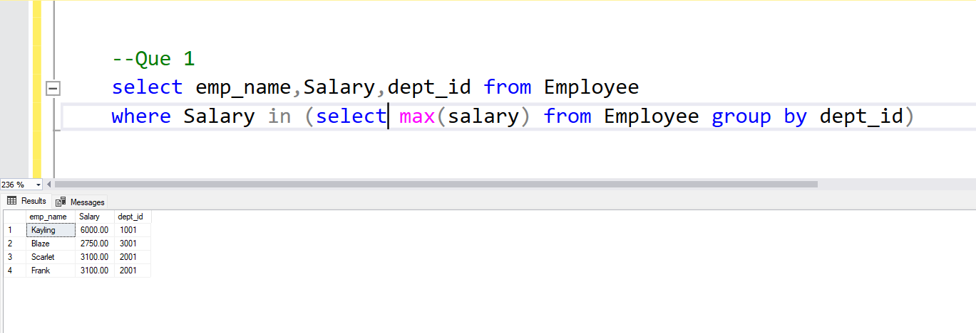

2. write a SQL query to find Departments that have less than 3 people in it

Ans:

**Query:**

SELECT dept_name AS "Department Name",

COUNT(employee.dept_id) as

"Number Of People"

FROM Department

LEFT JOIN Employee

ON Department.dept_id=Employee.dept_id

GROUP BY dept_name

HAVING COUNT(employee.dept_id)<3

**OUTPUT:**

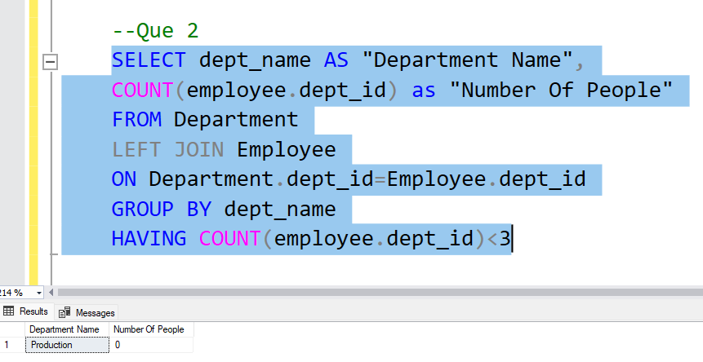

3. write a SQL query to find All Department along with the number of people there

Ans:

**Query:**

SELECT dept_name AS "Department Name",COUNT(employee.dept_id) AS "Number Of People"

from Department

LEFT JOIN Employee

ON Department.dept_id=Employee.dept_id

GROUP BY dept_name

**OUTPUT:**

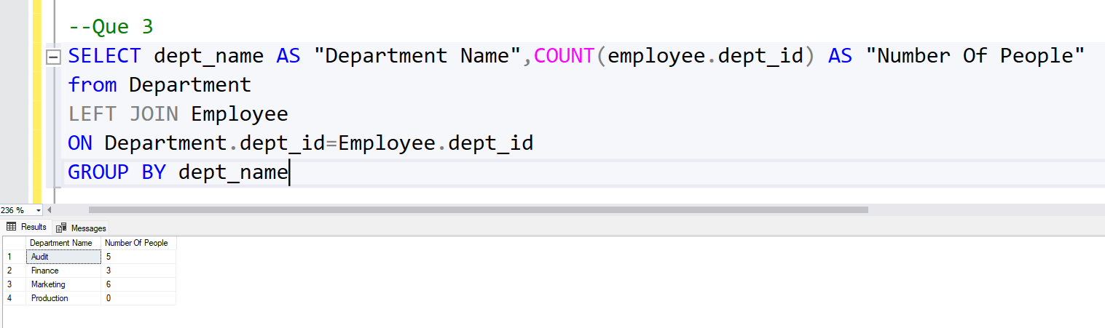

4. write a SQL query to find All Department along with the total salary there

Ans:

**Query:**

SELECT dept_name AS "Department Name",ISNULL(SUM(salary),0) AS "Total Salary"

FROM Department

LEFT JOIN Employee

ON Department.dept_id=Employee.dept_id

GROUP BY dept_name

**OUTPUT:**

